Designation: D 525 – 01

Designation: 40/97

An American National Standard
British Standard 4347

Standard Test Method for
Oxidation Stability of Gasoline (Induction Period Method)1

This standard is issued under the fixed designation D 525; the number immediately following the designation indicates the year of original adoption or, in the case of revision, the year of last revision. A number in parentheses indicates the year of last reapproval. A superscript epsilon (e) indicates an editorial change since the last revision or reapproval.

This test method has been approved by the sponsoring aommittees and accepted by the Cooperating Societies in accordance with established procedures.

This standard has been approved for use by agencies of the Department of Defense.

1. Scope
1.1 This test method covers the determination of the stabil- ity of gasoline in finished form only, under accelerated oxida- tion conditions. (Warning— This test method2 is not intended for determining the stability of gasoline components, particu- larly those with a high percentage of low boiling unsaturated compounds, as these may cause explosive conditions within the apparatus. However, because of the unknown nature of certain samples, the pressure vessel assembly shall include a safety burst-disc in order to safeguard the operator.)

NOTE 1—For measurement of oxidation stability of gasoline by mea- surement of potential gum, refer to Test Method D 873, or IP Test Method 138.
NOTE 2—The precision data were developed with gasolines derived from hydrocarbon sources only without oxygenates.

1.2 The accepted SI unit of pressure is the kilo Pascal (kPa);
and for temperature in °C.
1.3 This standard does not purport to address all of the safety concerns, if any, associated with its use. It is the responsibility of the user of this standard to establish appro- priate safety and health practices and determine the applica- bility of regulatory limitations prior to use.

2. Referenced Documents
2.1 ASTM Standards:
D 873 Test Method for Oxidation Stability of Aviation Fuels
(Potential Residue Method)3
D 4057 Practice for Manual Sampling of Petroleum and
Petroleum Products4

1 This test method is under the jurisdiction of ASTM Committee D02 on Petroleum Products and Lubricants and is the direct responsibility of Subcommittee D02.14 on Stability and Cleanliness of Liquid Fuels.
Current edition approved June 10, 2001. Published July 2001. Originally published as D 525 – 39 T. Last previous edition D 525 – 00.
2 Further information can be found in the June 1978, January 1979, and June
1986 editions of the Institute of Petroleum Review.
3 Annual Book of ASTM Standards, Vol 05.01.
4 Annual Book of ASTM Standards, Vol 05.02.

E 1 Specification for ASTM Thermometers5
2.2 IP Standards:
IP-138 Test Method for Oxidation Stability, Aviation Gaso- line6
Part IV—Petroleum and its Products7

3. Terminology
3.1 Definitions of Terms Specific to This Standard:
3.1.1 break point—the point in the pressure-time curve that is preceded by a pressure drop of exactly 14 kPa within 15 min and succeeded by a drop of not less than 14 kPa in 15 min.
3.1.2 induction period—the time elapsed between the plac- ing of the pressure vessel in the bath and the break point at
100°C.

4. Summary of Test Method
4.1 The sample is oxidized in a pressure vessel initially filled at 15 to 25°C with oxygen pressure at 690 to 705 kPa and heated at a temperature between 98 and 102°C. The pressure is recorded continuously or read at stated intervals until the breakpoint is reached. The time required for the sample to reach this point is the observed induction period at the temperature of test, from which the induction period at 100°C can be calculated. (Warning—In addition to other precautions, to provide protection against the possibility of explosive rupture of the pressure vessel, the pressure vessel should be operated behind an appropriate safety shield.)

5. Significance and Use
5.1 The induction period may be used as an indication of the tendency of motor gasoline to form gum in storage. It should be recognized, however, that its correlation with the formation

5 Annual Book of ASTM Standards, Vol 14.03.
6 Available from Institute of Petroleum, 61 New Cavendish St., London WIM,
8AR U.K.
7 A convenient template for measuring the breakpoint is described in the paper by Korb, E. L., “Induction Period Calculator,” ASTM Bulletin, No. 153, August 1948, pp. 99–102.

Copyright © ASTM, 100 Barr Harbor Drive, West Conshohocken, PA 19428-2959, United States.

1

D 525

of gum in storage may vary markedly under different storage conditions and with different gasolines.

6. Apparatus
6.1 Oxidation Pressure Vessel, Glass Sample Container and Cover, Accessories, Pressure Gage, and Oxidation Bath, as described in Annex A1.
6.2 Thermometer, having a range as shown as follows and conforming to the requirements as prescribed in Specification E 1 or in the specifications for IP thermometers:

NOTE 3—Other temperature sensing devices that cover the temperature range of interest, such as thermocouples or platinum resistance thermom- eters, that can provide equivalent or better accuracy and precision, may be used in place of thermometers specified in 6.2.
Thermometer Number
Temperature Range ASTM IP
95 to 103°C 22C 24C

7. Reagents and Materials
7.1 Gum Solvent—Mixture of equal volumes of toluene and acetone, both of which shall be of 99 % minimum purity.
7.2 Oxygen—Commercially-available extra-dry oxygen of not less than 99.6 % purity.

8. Sampling
8.1 Sample in accordance with the procedure for oxidation stability as described in Practice D 4057.

9. Preparation of Apparatus
9.1 Wash the glass sample container with gum solvent until free from gum. Rinse thoroughly with water and immerse the sample container and cover in detergent cleaning solution. The type of detergent and conditions for its use shall match the cleanliness obtained by the use of a strongly oxidizing agent such as chromosulfuric acid, ammonium peroxydisulfate in concentrated sulfuric acid at approximately 8 g/L, or sulfuric acid itself, soaking for at least 12 h, followed by rinses in tap water, distilled water and then acetone. For comparison, visual appearance and weight loss on heating the glassware under test conditions may be used. Glassware needs to show no signs of discoloration or particulates on the surface. The weight of glassware must not change by more than 6 0.5 mg between cleaning and heating/cooling cycles. Detergent cleaning avoids the potential hazards and inconveniences related to handling corrosive chromic acid solutions; this procedure remains the reference cleaning practice and as such may function as an alternate to the preferred procedure, cleaning with detergent solutions.
9.2 Remove container and cover from the cleaning solution by means of corrosion-resistant steel forceps and handle only with forceps thereafter. Wash thoroughly, first with tap water, then with distilled water, and dry in an oven at 100 to 150°C for at least 1 h.
9.3 Drain any gasoline from the pressure vessel and wipe the inside of the pressure vessel and pressure vessel closure, first with a clean cloth moistened with gum solvent and then with a clean dry cloth. Remove the filler rod from the stem and carefully clean any gum or gasoline from the stem, rod, and needle valve with gum solvent. The pressure vessel, the valve,

and all connecting lines shall be thoroughly dry before each test is started. (Warning—Volatile peroxides which may have formed during a previous test may accumulate in the equip- ment, producing a potentially explosive environment. Special care in cleaning after each test is needed to ensure the filler rod, stem, and needle valve are free of these peroxides.)

10. Procedure
10.1 Bring the pressure vessel and the gasoline to be tested to a temperature of 15 to 25°C. Place the glass sample container in the pressure vessel and add 50 6 1 mL of test specimen. Alternatively, transfer 50 6 1 mL of test specimen into the glass sample container first, before placing the glass sample container into the pressure vessel. Cover the sample container, close the pressure vessel, and using a quick release air coupling introduce oxygen until a pressure of 690 to 705 kPa is attained. Allow the gas in the bomb to escape slowly in order to flush out the air originally present (Release the pressure at a slow uniform rate through the needle valve at a rate not to exceed 345 kPa per min). Introduce oxygen again until a pressure of 690 to 705 kPa is attained and observe for leaks, ignoring an initial rapid drop in pressure (generally not over 40 kPa) which may be observed because of the solution of oxygen in the sample. When the rate of pressure drop does not exceed 7 kPa in 10 min, assume the absence of leaks and proceed with the test without repressuring.
10.2 Place the charged pressure vessel in the vigorously boiling water bath, or appropriate liquid bath equipped with mechanical stirring, being careful to avoid shaking, and record the time of immersion as the starting time. Maintain the temperature of the liquid bath between 98 and 102°C. Observe the temperature to the nearest 0.1°C at intervals during the test, and record the average temperature to the nearest 0.1°C as the temperature of the test. Make a continuous record of the pressures in the pressure vessel, or if an indicating pressure gage is used, take pressure readings at 15-min intervals or less. If, during the initial 30 min of the test, a leak develops (as indicated by a steady drop in pressure considerably in excess of
14 kPa in 15 min) discard the test. Continue the test until reaching a point preceded by a pressure drop of exactly 14 kPa in 15 min and succeeded by a drop of not less than 14 kPa in
15 min or until the induction period exceeds the product specification. (Warning—If a boiling water bath is used and the test is made in a region where the atmospheric pressure is consistently below normal (101.3 kPa), it is permissible to add a liquid with higher boiling point, such as ethylene glycol, to the water in order to maintain the operating temperature of the bath in the neighborhood of 100°C. If a liquid other than water is used, be sure the liquid is compatible with the seals in the pressure vessel.)
10.3 Record the number of minutes from the time the pressure vessel is placed in the bath until the breakpoint has been reached as the observed induction period at the tempera- ture of the test.
10.4 Cool the pressure vessel to approximately room tem- perature within 30 min after removal from the bath, using ambient air or water # 35°C, before releasing the pressure slowly from the pressure vessel through the needle valve at a rate not exceeding 345 kPa per minute. Wash the pressure

2

vessel and sample container in preparation for the next test.

11. Calculation
11.1 The number of minutes from the time the pressure vessel is placed in the bath until the breakpoint has been reached is the observed induction period at the temperature of the test.
11.2 Method of Calculation—Calculate the induction period at 100°C from one of the following equations: (a) When the test temperature is above 100°C:

Induction period at 100°C 5~IPt!~1 1 0.101~t a 2 100!! (1)
(b) When the test temperature is below 100°C:

Induction period at 100°C, min 5 ~IP t!/~1 1 0.101~100 2 tb!! (2)

where:
IPt = induction period, min, at the temperature of the test,
ta = test temperature when above 100°C, °C, and
tb = test temperature when below 100°C, °C.

12. Report
12.1 Report the Induction period at 100°C, calculated as in
11.2 to the nearest 1 min.
12.2 If the test was stopped prior to observing the pressure drop required in 10.2, but after the product specification was exceeded, then report the result as being greater than N min, where N is the product specification in min.

13. Precision and Bias
13.1 The precision of the test method as determined by
D 525

statistical examination of interlaboratory test results is as follows:
13.1.1 Repeatability—The difference between two test re- sults, obtained by the same operator with the same apparatus under constant operating conditions on identical test material, would in the long run, in the normal and correct operation of the test method, exceed the following values only in one case in twenty: 5 %.
13.1.2 Reproducibility—The difference between two single and independent results obtained by different operators work- ing in different laboratories on identical test material would, in the long run, in the normal and correct operation of the test method, exceed the following values only in one case in twenty: 10 %.
13.2 Bias—There being no criteria for measuring bias in these test-product combinations, no statement of bias can be made.

NOTE 4—The precision values given above for induction period were obtained using a boiling water bath only as the heat source. Therefore, these precision values are not necessarily applicable to induction period results obtained using other heat sources.

14. Keywords

14.1 breakpoint; gasoline; induction period; oxidation sta- bility

ANNEX

(Mandatory Information)

A1. APPARATUS

A1.1 Apparatus

A1.1.1 Pressure Vessel—The pressure vessel shall be made of corrosion-resistant steel with the inside dimensions of the portion that encloses the reacting gasoline-oxygen mixture conforming substantially to those shown in Fig. A1.1. Fig. A1.1 is a composite drawing of specific pressure vessels and related apparatus for performing Test Method D 525 as made by various manufacturers. As such, ranges of specific dimen- sions have been given and are not intended to be precise. Pressure vessels conforming to Test Method D 525/1980-1995 as well as IP 40 are also suitable, but the specified burst-disc shall be attached. Small variations in external dimensions are not considered to significantly impact the results of the test, but specific studies to document potential effects, if any, have not been carried out. A minimum wall thickness of 5 mm in the pressure vessel is specified for safety reasons. (Warning— Pressure vessel assembly components obtained from different suppliers/manufacturers may not be compatible.)
A1.1.1.1 The interior surfaces of the pressure vessel and pressure vessel closure shall have a high polish such as a

surface roughness of 0.20 to 0.40 micrometres, to facilitate cleaning and to prevent corrosion.
A1.1.1.2 Other structural details, such as method of closure,
(polygonal or knurled) gasket material, and outside dimensions are optional provided the limitations listed in A1.1.1.3 and A1.1.1.4 are observed:

NOTE A1.1—Initial testing and periodic examination of the pressure vessel should be carried out to ensure its fitness for service.

A1.1.1.3 The pressure vessel shall be constructed to with- stand a working pressure of 1240 kPa at 100°C, with an ultimate strength at least equal to that of a pressure vessel constructed of 18 % (m/m) chromium, 8 % (m/m) nickel-alloy steel. A suitable material is an alloy steel conforming to the specification for 303 or 304 stainless steels.
A1.1.1.4 The closure shall be capable of making a seal that will not leak when the pressure vessel is filled with oxygen to
690 to 705 kPa at 15 to 25°C and plunged into a bath at 100°C. It is preferable that the closure ring be constructed from an alloy different from that of the body if the mating threads of the two parts are to move with respect to each other when the

3

D 525

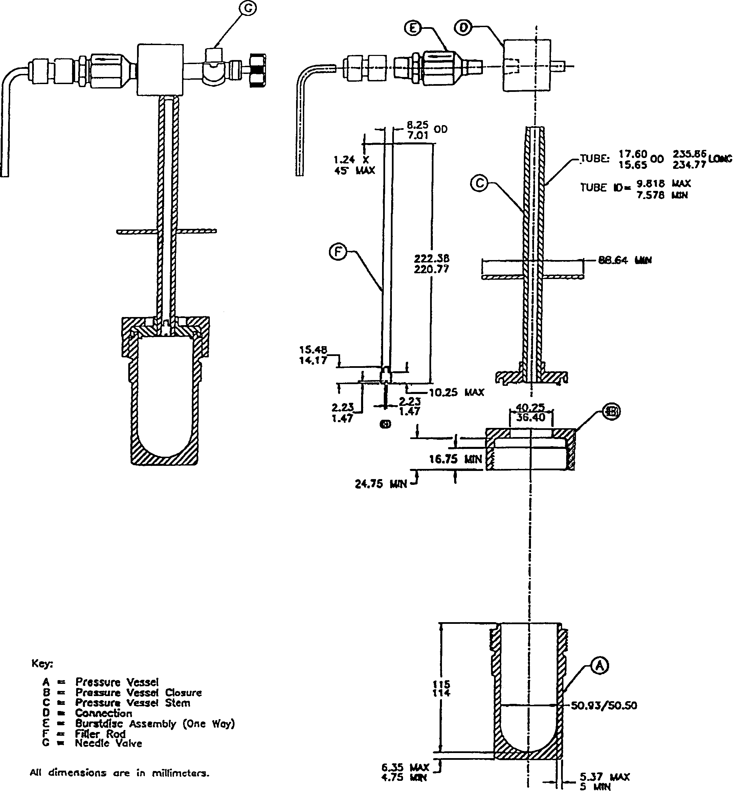

NOTE 1—The dimensions on the burt dis outlet pipe are: internal diameter – 3.7 mm id, min radius – 14.95 mm, min length – 35 by 75 mm, typical or approximate.
FIG. A1.1 Composite Pressure Vessel for Oxidation Stability Test of Gasoline

tightening load is applied.
A1.1.2 Gasket—Any suitable gasket material will pass the test described in A1.1.2.1.
A1.1.2.1 Place a gasket of the type under test in the pressure vessel in the absence of gasoline and use a similar gasket to

make the seal with the pressure vessel closure. Fill the pressure vessel with oxygen at a pressure of 690 to 705 kPa and immerse in a bath at about 100°C. If the pressure does not drop more than 14 kPa from the maximum in a 24-h period with the bath temperature constant at6 1.0°C, the gasket shall be

4

considered satisfactory.
A1.1.3 Glass Sample Container and Cover, conforming to the dimensions given in Fig. A1.2.
A1.1.3.1 Cover, capable of keeping material refluxing back through the pressure vessel stem from entering the sample but not to prevent free access of oxygen to the sample. One such example of a cover is shown in Fig. A1.2, where the identified dimensions have been found suitable to use.
A1.1.4 Pressure Vessel Stem—A stem with a filler rod, constructed of the same material as the pressure vessel closure, and having dimensions conforming to those shown in Fig. A1.1.
A1.1.4.1 The filler rod and the inside of the stem shall have a high polish such as surface roughness of 0.20 to 0.40 micrometres to facilitate cleaning and prevent corrosion. The stem shall be fitted, in the position shown in Fig. A1.1, with a circular metal plate 89 mm in diameter to serve as a closure for the bath when the pressure vessel is in place.
A1.1.5 Burst-disc Assembly—The stem shall be fitted with a stainless steel burst-disc assembly which will rupture if sub- jected to a pressure greater than 1530 kPa 6 10 %. The assembly shall be mechanically designed to ensure that it cannot be incorrectly fitted. (Warning—Provision shall be made to safely vent any expelled gases or flames away from the operator, other personnel, or flammable materials as a safety precaution if the burst disc ruptures.)
A1.1.6 Connection—Provision shall be made for connect- ing a pressure gage and a tightly closing needle valve to the pressure vessel stem as shown in Fig. A1.1. A quick release air coupling fitted to the needle valve shall be used to facilitate oxygen entry to the pressure vessel.
A1.1.7 Needle Valve—A control valve suitable for complete shut off but fitted with a finely tapered needle and orifice.
D 525

NOTE A1.2—The valve should be used while purging, pressurising, and exhausting the pressure vessel with oxygen.
A1.1.8 Pressure Gage—An indicating or a recording type gage reading to at least 1380 kPa. Pressure transducers and digital readout devices may be used provided that accuracy of measurement is not adversely affected.
A1.1.8.1 Any half of the scale interval (that is, 345 kPa) between 690 and 1380 kPa shall be at least 25 mm in length measured along the arc of the scale. The intervals of division shall be 35 kPa or less. The accuracy shall be 1 % or less of the total scale interval. Other suitable equivalent metric gages may be used.
A1.1.8.2 The gage shall be connected to the pressure vessel directly or by flexible metal or metal sheathed gas-resistant polymeric tubing having a pressure rating to satisfy the above conditions. The total volume of the flexible tubing, connec- tions, and stem with filler rod in place, shall not exceed 30 mL.
(Warning—When ordering equipment for this test, the manu- facturer should be requested to ensure pressure gage and needle valve are suitable for use with oxygen.)
A1.1.9 Oxidation Bath—The liquid bath shall have a capac- ity of not less than 18 L for one pressure vessel, plus 8 L for each additional pressure vessel in multiple assemblies, and be of such dimensions that the maintained depth of the bath liquid is not less than 290 mm. A non-self-resettable device shall be fitted on all baths supplied to ensure that the heater is switched off if the bath liquid falls below a safe level and to prevent the bath from boiling dry. Users of older baths without this device are strongly urged to have the equipment retrofitted to ensure safe operation.
A1.1.9.1 The top of the bath shall have openings of a suitable diameter to accommodate the pressure vessel and to fit the cover plate fastened to the pressure vessel stem. If a

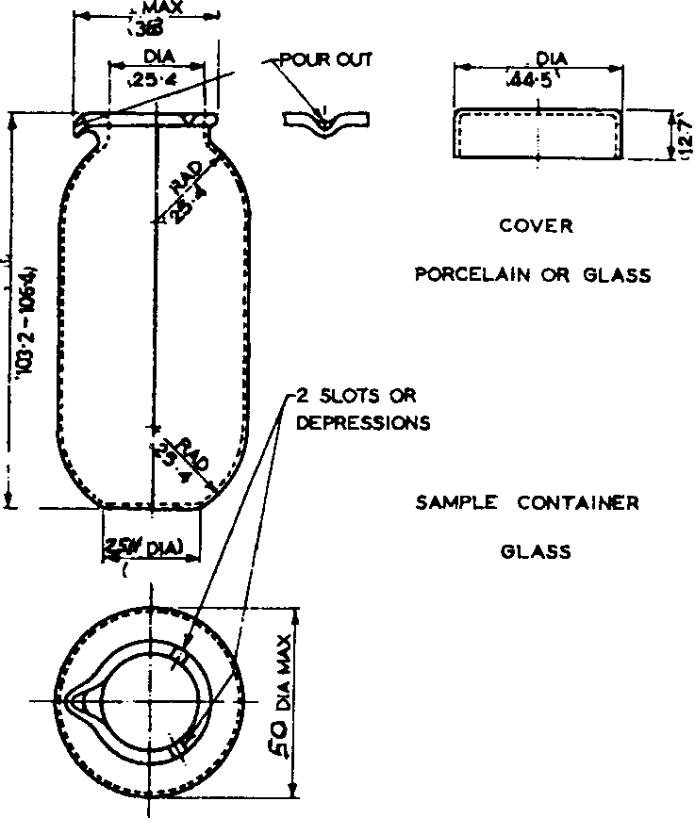

NOTE 1—All dimensions are millimetres.
NOTE 2—One of the V-shaped depressions shall be depressed sufficiently to serve as a pouring lip.
NOTE 3—Glass sample container, the dimensions on the flat bottom, inner diameter (near the opening), and the internal radius of the curved sides are
25.4 6 2.0 mm. The width of the container at its widest point is 50 6 2 mm.
NOTE 4—Glass sample cover, the outside diameter is 44.5 6 2.0 mm and the height is 12.7 mm, max.
FIG. A1.2 Glass Sample Container and Cover (Glass or Porcelain)

5

thermometer is being used to monitor bath temperature, a thermometer well shall be provided in such a position that the
97°C mark of the thermometer is above the cover of the bath. For other temperature sensing devices, the bath shall have provisions to allow for the temperature to be monitored appropriately.
A1.1.9.2 When in place, the top of the pressure vessel closure shall be submerged at least 50 mm below the surface of the bath liquid.
A1.1.9.3 Auxiliary lids are needed to cover the openings when the pressure vessels are not in the baths. The bath shall be provided with a condenser and source of heat to maintain the bath water boiling vigorously. If a liquid medium other than water is used, an appropriate mechanical stirrer/mixer shall be used to maintain uniformity of the liquid bath at 100 6 2°C.
D 525

NOTE A1.3—Electric heating blocks are known to be used. These blocks can have heat capacities, heating rates, and heat transfer charac- teristics which differ from those of a liquid bath. An electric heating block may be used in place of a liquid bath as long as the sample heating rate and sample temperature are demonstrated to be equivalent to that of the liquid bath.

A1.1.10 Thermometer, having a range from 95 to 103°C, conforming to the requirements prescribed in Specification E 1 or in the Specifications for IP thermometers. Other temperature sensing devices that cover the temperature range of interest, such as thermocouples or platinum resistance thermometers, that can provide equivalent or better accuracy and precision, may be used in place of the thermometers specified in 6.2.

The American Society for Testing and Materials takes no position respecting the validity of any patent rights asserted in connection with any item mentioned in this standard. Users of this standard are expressly advised that determination of the validity of any such patent rights, and the risk of infringement of such rights, are entirely their own responsibility.

This standard is subject to revision at any time by the responsible technical committee and must be reviewed every five years and if not revised, either reapproved or withdrawn. Your comments are invited either for revision of this standard or for additional standards and should be addressed to ASTM Headquarters. Your comments will receive careful consideration at a meeting of the responsible technical committee, which you may attend. If you feel that your comments have not received a fair hearing you should make your views known to the ASTM Committee on Standards, at the address shown below.

This standard is copyrighted by ASTM, 100 Barr Harbor Drive, PO Box C700, West Conshohocken, PA 19428-2959, United States. Individual reprints (single or multiple copies) of this standard may be obtained by contacting ASTM at the above address or at
610-832-9585 (phone), 610-832-9555 (fax), or service@astm.org (e-mail); or through the ASTM website (www.astm.org).

6

